Chapter No. 01
School Management System
1.1 About the Project
This School Management System has been designed for “GOVT.POST GRADUATE COLLEGE OF MANAGEMENT SCIENCES CHITRAL”. This database/SMS in connection to computerized the School setup and maintain of daily activities, behind the accounting purpose, the system has also been designed for making decision for financial position of school. The system is totally PC based program and can be run on any Operating System environment.
The SMS – School Management System – Is highly professional software designed to meet the ever growing needs of any school. The Software is divided into several modules which are Students detail, Student result detail, Student emergency contacts, Teachers detail and Students fee details. The system has a system administrator module for security management.
1.2 Purpose
The purpose of developing School management system is to computerized the tradition way of performing daily school activities. Another purpose for developing this software is to generate the report automatically in an easy manner.
1.3 Scope
The scope of the project is the system on which the software MS Access is installed, i.e. the project is developed as a desktop application, and it will work for a particular institute.
1.4 Introduction of GOVT.POST GRADUATE COLLEGE OF MANAGEMENT SCIENCES CHITRAL
GOVT.POST GRADUATE COLLEGE OF MANAGEMENT SCIENCES CHITRAL
is a private institute, which is situated, in Chitral town, in a peaceful and natural environment. DPS offers classes from Nursery to Degree level. However this SMS is prepared to manage the daily activities up to Intermediate class level.
Commerce College is one of the earliest educational institutes in Chitral; it provides a quality education in different educational fields. Commerce College has a Principal and highly qualified teaching staff. All the school activities in Commerce College are performed manually and on paper.

Chapter No. 02
Present System & Feasibility Study
2.1 Present System
In the present system all work is done on paper. The whole day activities are stored in registers and at the end of the session the reports are generated. All the sections i-e Admission, Exams, Staff and Account have their own separate registers. These registers are used for record keeping and manipulating student’s information.
2.2 Disadvantages of Present System
- Not User Friendly: The existing system is not user friendly because the retrieval of data is very slow and data is not maintained efficiently
- Difficulty in report generating: We require more calculations to generate the report so it is generated at the end of the session.
- Manual control: All calculations to generate report are done manually so there is greater chance of errors.
- Lots of paperwork: Existing system requires lot of paper work. Loss of even a single register/record led to difficult situation because all the papers are needed to generate the reports.
- Time consuming: Every work is done manually so we cannot generate report in the middle of the session or as per the requirement because it is very time consuming.

2.3 Feasibility Study
2.3.1 Economically Feasibility:
The system being developed is economic with respect to School or Collage’s point of view. It is cost effective in the sense that has eliminated the paper work completely.
The system is also time effective because the calculations are automated which are made at the end of the month or as per the user requirement.
The result obtained contains minimum errors and are highly accurate as the data is required.
2.3.2 Technical feasibility:
The technical requirement for the system is economic and it does not use any other additional Hardware and software.
2.3.3 Behavioral Feasibility:
The system working is quite easy to use and learn due to its simple but attractive interface. User requires no special training for operating the system.

2.4 Solutions for Present System

- The School Management System is n totally computer based system and it is easy to use and store records. This method can help to reduce a lot of energy and workforce.
- The system is also can be protected by password to restrict unauthorized access.
- All data is keyed in the system and save in the database for later use rather than writing and keeping the document in a rack to make sure that the data is more safely secured.
- Data is safely kept –in a soft copy and backup copies rather than hardcopies to safe a lot of documents and folders room space and also to reduce papers usage.
- Management, updates and keeping track of data is easily done in just clicking some buttons to get the specific data, for example to search for student detail we have to give only the student roll number and class and the click search.

Chapter No. 03
Proposed System
3.1 Introduction
After the thorough analysis of the shortcomings of the existing system, it is felt to remove the deficiencies of the existing system by introducing a computerized system. It means a system to change it form manual to a full computer based system which will help the management to perform different tasks in no time.
3.2 Characteristics of the Proposed System
- User Friendly: The proposed system is user friendly because the retrieval and storing of data is fast and data is maintained efficiently. Moreover the graphical user interface is provided in the proposed system, which provides user to deal with the system very easily.
- Reports are easily generated: reports can be easily generated in the proposed system so user can generate the report as per the requirement (monthly) or in the middle of the session.
- Very less paper work: The proposed system requires very less paper work. All the data is feted into the computer immediately and reports can be generated through computers. Moreover work becomes very easy because there is no need to keep data on papers.
- Computer operator control: Computer operator control will be there so no chance of errors. Moreover storing and retrieving of information is easy. So work can be done speedily and in time.
3.3 Objectives of the proposed system
Following are the main objectives that the proposed system must be meet.
- To get rid of the problems add drawbacks present in the existing system and introduce an organized way of keeping information.
- To provide an easy way of online system.
- To develop a fast and efficient system.

Chapter No. 04
Database Terminologies and ERD

4.1 Entity
An entity is a person, place, thing, or event for which data is collected and maintained. Thus entity has a noun name. Some examples of each of these kinds of entities follow:
Person: STUDENT, EMPLOYEE, PATIENT
Place: STORE, WAREHOUSE, STATE
Object: MACHINE, BUILDING, AUTOMOBILE
Event: SALE, REGISTRATION, ADDMISSION
Concept: ACCOUNT, COURSE [i]
Entities are written in Upper case letters. Entity is denoted by a rectangle symbol in ERD.

4.2 Entity Type
The collection of entities having similar attributes is called Entity type. It is the basic elements of entity relationship diagram. It can represent physical object such as people and place as well as events such as payment. Entity type is denoted by rectangle, the properties of entity type are called attributes and each attribute has a data type.
  - Attribute
A property or characteristic of an entity or relationship type that is of interest to the organization is called attribute. Following are some typical entity types and their associated attributes.
STUDENT Class_Roll_no, Student_Name, Address, Phon_Number AUTOMOBILE Vehicle_ID,Color, Weight, Horsepower
EMPLOYEE Employee_ID, Employee_Name, Skill [ii]

  - Relationship
A relationship is an association, linkage, or connection between the entities. The relationship may be between different entities or between an entity and itself.
Relationship represents an association between two or more entities. An example of a relationship would be:
• TEACHER teaches the STUDENT
• STUDENT studies COURSE [iii]

  - Entities for the Proposed System
The Entities and its attributes for the proposed system are as below:
STUDENT Class_Roll_No, Name, F/Name, Address, Technology etc.
FEE Addmison Fee, Monthly_Tution_Fee, Security_Fee, Board_Exam_Fee etc.
RESULT Total_Marks, Obtained_Marks, Percentage, Pass_Fail, Remarks
TEACHER Name, F/Name, Address, Cell_No, Subjects etc.
4.6 E-R model
The entity-relationship (E-R) data model perceives the real world as consisting of basic objects, called entities, and relationships among these objects. It was developed to facilitate database design by allowing specification of an enterprise schema, which represents the overall logical structure of a database. The E-R data model is one of several semantic data models; the semantic aspect of the model lies in its representation of the meaning of the data. The E-R model is very useful in mapping the meanings and interactions of real-world enterprises onto a conceptual schema. Because of this usefulness, many database-design tools draw on concepts from the E-R model. [iv]

4.6.1 Symbol Used in ERD
This Rectangle symbol represents the entity.
This diamond symbol represents a relationship between the entities.
This ellipse symbol represents an attribute.

4.6.2 Relationship Types
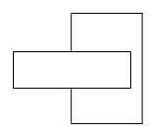This symbol represents a unary relationship.
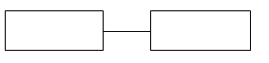This symbol represents a binary relationship.

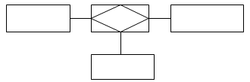 This symbol represents ternary relationship.
4.6.3 Modality
Number of instances of an entity that can be associated with each instance of another entity is called modality.
The following symbols are used to show the modality.
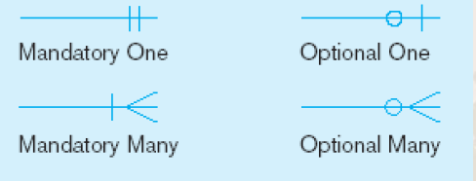

4.7 Advantages of ER Model
Some of the important advantages of ER model are as follows:
- Visual representation: The foremost and most important ERD benefit is that it provides a visual representation of the design. It is normally a crucial to have an ER model for an effective database design.
- Effective communication: An ERD clearly communicates the key entities in a certain database and their relationship with each other. This allows a designer to effectively communicate what exactly the database will be like. Thus the designer is able to satisfy the user and other stack holders about the database design.
- Simple to understand: ERD is easy to understand and simple to create. In effect, this simple design can be used to be shown to the representatives for approval.

4.8 ERD for the Proposed System
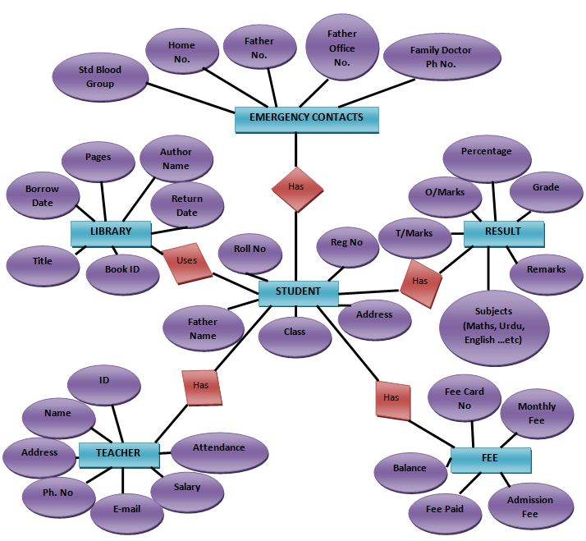
Figure 1 ERD of the Proposed System

Chapter No. 05
User Interface Design
5.1 User Interface
It is particularly important first to design how the system will look and respond to user before designing the software structure. The most critical and creative aspect of development is to design the user interface. User interface design determines how the system will look to the user from outside. The basic design principles, considered during the user interface are following
- Consistent
- Make sense
- User friendly
- Flexibility and simple
5.1.1 Consistency
Consistency is the ability of user to predict that the software is going to do in a given situation based on the past experience with the product. It means to provide the sets of behavior in the response to user actions and generalized knowledge about one aspect of the system to other aspects.
5.1.2 Make sense
Good user interface gives user clues about what to do next in a given situation. It means to provide clear and obvious ways for the user to get something done.
5.1.3 User friendly
To make the system user friendly, right level and right level of response should be given to user against each user action with an input device. Lack of proper feed back can be a big problem when nothing appears to have happened. In design of many projects proper and immediate feedback is provided at different stage to make the system user friendly.

5.1.4 Flexibility and Simplicity
It means system should be so simple and flexible that user is able to concentrate on getting task done at hand with a minimum of distraction. The system is also made simple by reducing redundancy.
5.2 Table
Tables consist of rows and columns. Tables are used to store data in the database.
5.3 Queries
Queries are the primary mechanism for retrieving information from a database and consist of questions presented to the database in a predefined format. [v]
5.4 Report
A report presents information retrieved from a table or query in a preformatted, attractive manner. [vi]
5.5 Form
A Form is a screen or window that contains numerous fields or spaces to enter data. A form is more user friendly than generating queries to create tables and insert data into the fields. [vii]
5.6 Switched board
A Switched board is a form that allows you to navigate around your Access database. The switched board is made of buttons that we click. We can program these buttons to open forms, reports, queries, etc. [viii]
5. 7 Switch board in SMS
When we opened the SMS in MS Access environment, then the Switched board of SMS will opened by default. It consists of following different buttons:
- STUDENT DETAIL FORM
- RESULT DETAIL FORM
- FEE DETAIL FORM
- LIBRARY DETAIL FORM
- STUDETN EMERGENCY CONTACTS
- TEACHER DETAIL FORM
Each button is used to open a particular form in edit mode.

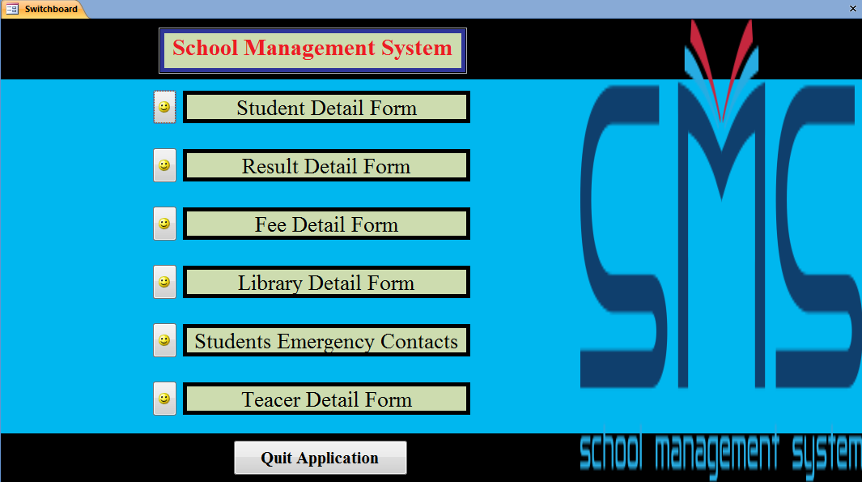
Figure 2 Screenshot view of Switchboard

5.8 Forms in SMS
There are different forms in SMS. These are
5.8.1 Student Detail Form
Student detail form is used to add information about a student in STUDENT table. When on switched board, if we click on STUDENT DETAIL button then student form will opened. This from contains different fields to enter data about the students.

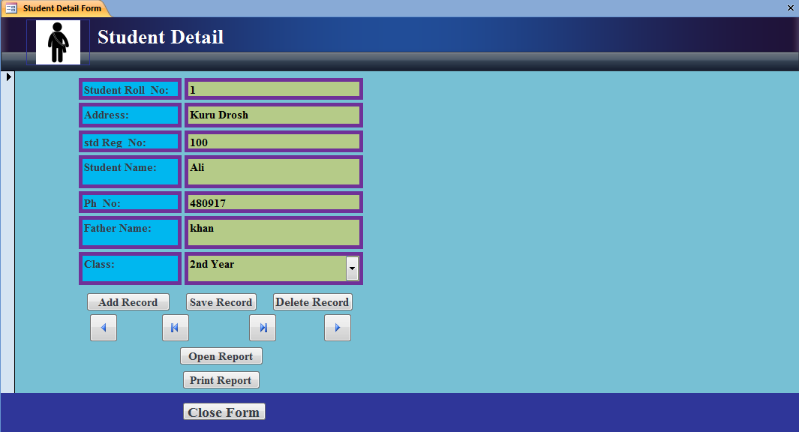
Figure 3 Screenshot View of Student Detail Form

5.8.2 Student Fee Detail Form
Student Fee form is used to insert data about the students fee. By clicking on STUDENT FEE DETAIL button this form will be opened.
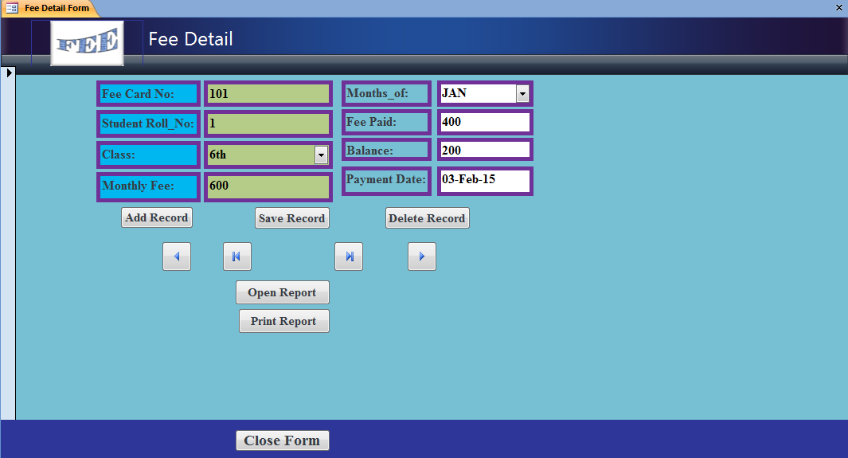
Figure 4 Screenshot view of Student fee detail form

5.8.3 Student Result Form
Student Result form is used to insert student result information into student RESULT table. This form also calculates Total_Marks, Percentage, Grade, Pass/Fail and Remarks automatically when we move cursor above the related fields.
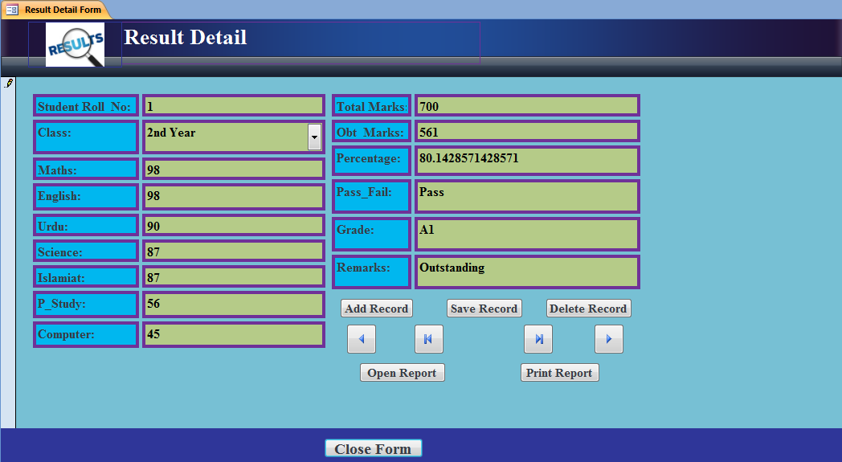
Figure 5 Screenshot view of Student Result Form

5.8.4 Teacher Details Form
This form is used to insert details about Teachers.
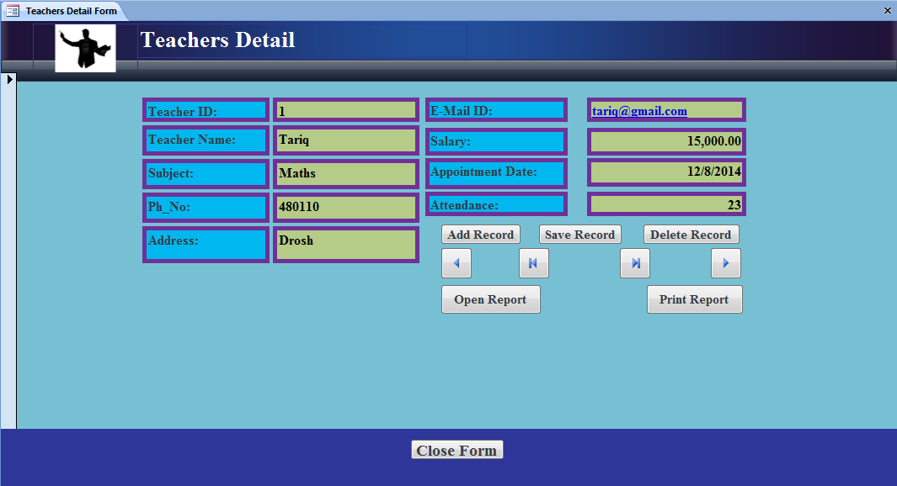
Figure 6 Screenshot View of Teacher Detail form

5.8.5 Student Emergency Contacts Form
This form is used to add or view student’s emergency contacts. It contains different emergency numbers and blood group of a student. So in case of any accident all the contacts can be viewed very easily.
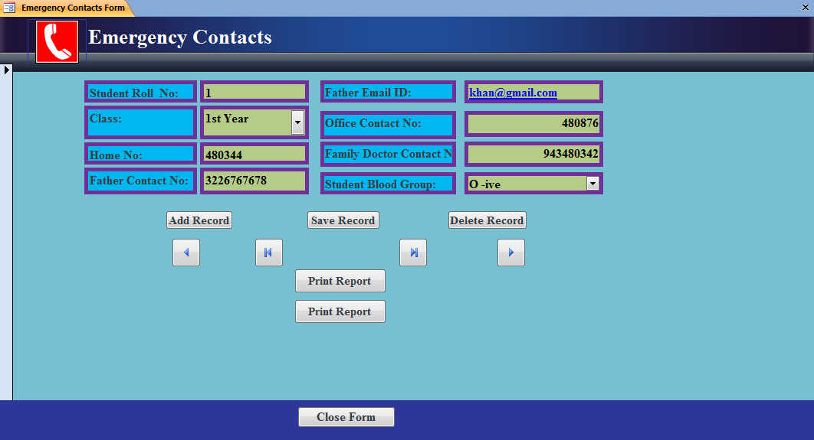
Figure 7 Screenshot View of Emergency Contacts detail form

5.8.6 Library Detail Form
This form is used to insert records of student who uses library for borrowing books. All the record about book borrowing can be inserted using this form. Also the detail of students who borrowed books from library can also viewed by using this form.
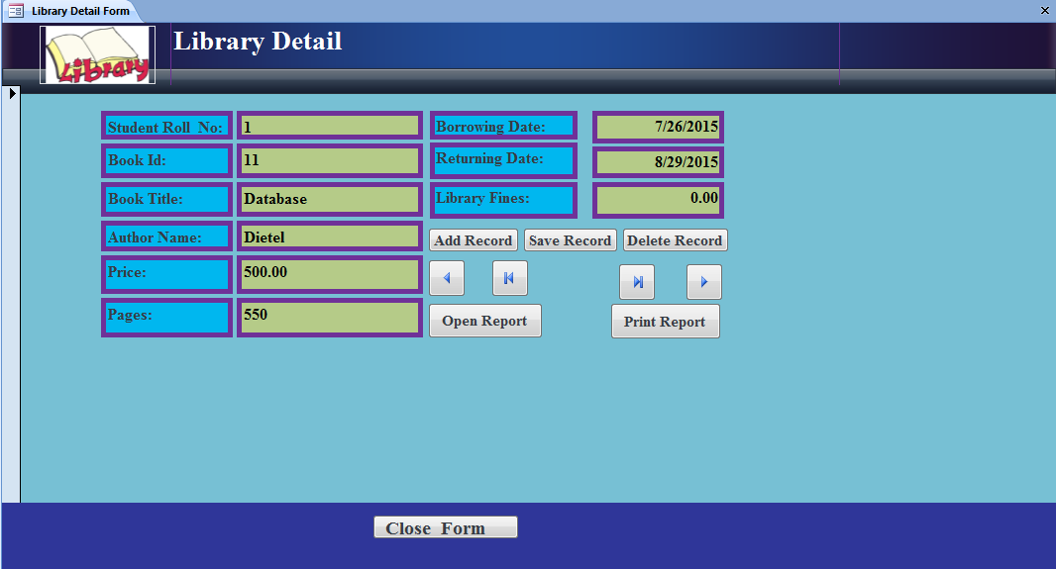
Figure 8 Screenshot view of Library detail Form

5.9 Reports and Querries in SMS
There are many reports and Querries in SMS. Reports are used to show the data in attractive manner. While query is used to get the desired data from the tables; Querries are question asked by user from the database.
5.9.1 Student Detail Report
To show the details of all Student this reports is used.
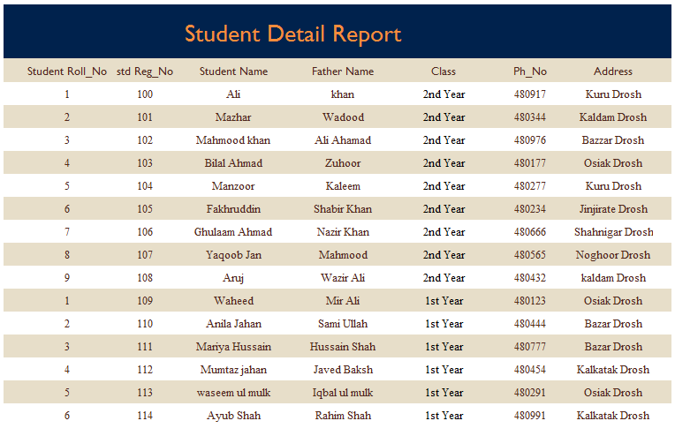
Figure 9 Screen Shot View of Student Detail Report

5.9.2 Result Detail Report
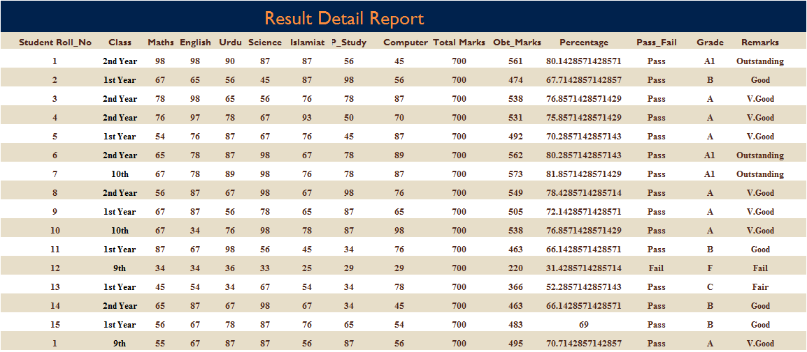
This report shows the details of results of students this report is used.

Figure 10 Screen Shot View of Result Report

The SMS also contains different other reports such as Fee report, Library report, Contacts report and Teacher report etc.

5.9.3 Query to get Result by Roll No and Class
This query is used to get the result detail by entering roll no. and class. When we run this query a dialog box open with the message “Enter Roll No” and “Enter Class” when we enter Roll No. and Class, this query shows the result detail of that student.
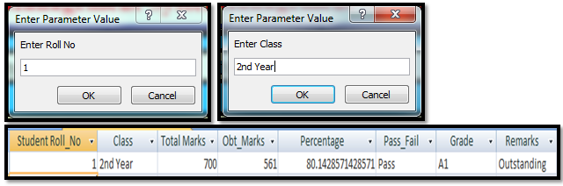
Figure 11 Screen Shot View of a Query in SMS

5.9.4. Other Queries in SMS
There is a list of queries in SMS. Some of them are:
Query to:
- Get all Students by class
- Get book borrowed Details by student by using roll number
- Get Fee Detail By Card No
- Get Result by Roll No and Class
- Get Student by Roll No and Class
- Get Student Details by Roll No and Class
- Get Students contacts by entering Roll No And Class
- Get Students contacts by entering Roll No And Class

5.10 Relationship in SMS
Relationship is used to connect table with each other. Relationship is achieved by means of Primary keys and foreign keys.
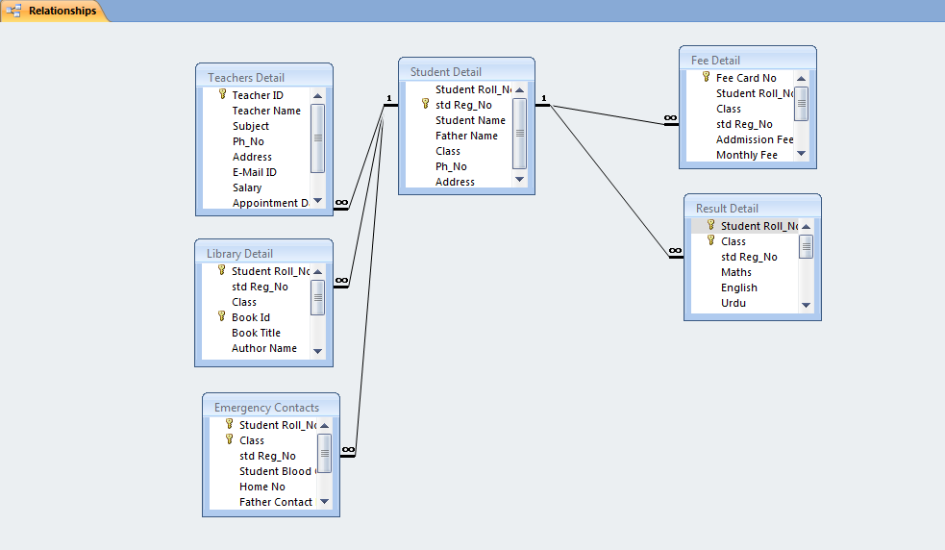
Figure 12 Screen Shot View of Relationship in SMS

Chapter No. 06
Testing and Implementation
6.1 Introduction
System testing is essential step for the development of a reliable and error free system in software development project errors can be introduced at any stage during the development. Each phase has its own techniques for the detection and correction of errors in that phase. However some requirements errors and design errors are likely to remain undetected. Ultimately these errors will be reflected in a code. Since code is the only product that can be executed and whose actual behavior can be observed, testing is the phase where the errors remaining from the early phases also must be detected. Testing is the process of detecting and correcting as many errors as possible in the developed software before delivery to the customer. Test case is specification of the test and the output from the system plus a statement of what is being tested. Test data are the inputs which have devised to test the system.
6.2 Testing Objectives
- To find errors in the developed software
- To check that working of the software function is according to the specifications, their behavior and performance requirement are fulfilled. To check the reliability and quality of the software.
6.3 Testing strategies
Following are the basics strategies that were used for testing of the software.
Black box testing
White box testing
Stress testing
Acceptance testing
Assertion testing

6.3.1 Black box testing
It can only be determined by studying its inputs and the related outputs. It is called functional testing because here the tester has only concerned with functionally and not with the implementation of the software. In black box testing only the functionality of the software was tested without a record o the code. If the functionality which was expected from a component is provided then the black box testing is completed.
6.3.2 White Box Testing
White box testing is also called glass box testing and structural testing. The objective of white box testing is not to exercise all the different input or out put condition but to exercise the different programming and data structure used in the program. In white box testing internal code return in every component was tested and it was checked that the code written is efficient in utilizing various resources of the system like memory etc.
6.3.3 Stress testing
Stress test is designed to confront program with abnormal situation. Stress testing executes system in a manner that demands rescore in abnormal quality frequency or volumes.
For example;
1: Input data rates may increase to determine how input function will respond
2: Tests that’s requires maximum memory or other resources are executed.
Basically, the tester wants to break the program.
In stress testing the software was tested against the boundary conditions. Various inputs fields were tested against
Abnormal values and it was tested that the software does not behave abnormally at any time.
6.3.4 Acceptance testing
Acceptance testing is performed with realistic data of the client to demonstrate that the software is working properly. In acceptance testing the software was checked for completeness that it is ready. Quality assurance department performs the acceptance testing that the software is ready and can be given to the customer.
6.3.5 Assertion Testing
In assertion testing the software is tested against the possible assertion. Assertion is used to check the program and various locations that whether the state of the program at a particular point is the same as expected or not.

6.3.6 Unit Testing
Unit testing focuses verification effort on software component or module which is the smallest unit of software design. The unit testing is white box oriented and it can be conducted in parallel for multiple components.
In unit testing we checked that all individual components were working properly. Before integration of all components unit testing is essential because it gives a confidence that all the component individually are working fine and ready to be integrated with the other ones.
6.4 System Testing
System testing is actually a series of different tests whose primary purpose is to fully exercise the computer based system. Although each test has a different purpose, all the work to verify that system elements have been properly integrated and perform allocated functions.
When all the units were working properly and unit testing was performed and checked the entire integrated component as a whole and looked for possible discrepancies, which could have arisen after the integration.
6.5 System Evaluation
The objectives of the system evaluation is to determine whether the desired of objectives have been accomplished or not. Determining the merits and demerits of the proposed system over the existing system is also covered in system evaluations. This is concerned with the detailed study of the developed system, from implementation point of view.

6.6 Implementation
This phase consists of bringing the new system in operation and turning it over the users.
Briefly involves the following steps.
- Training: it involves
- User groups
- Administrators

6.7 Installation of Computer Equipment
It involves:
- Locations
- Power supply
- Space requirements
- Air conditioning
6.8 Units Testing
In unit testing the different modules of software were test independently to locate errors. This helps in locating errors, in coding and logic that were contained within a particular module.
6.8.1 Integrated Testing
After unit testing combined testing of all modules was carried out. The purpose was to determine that all the modules are correctly integrating with each other.
6.8.2 System Testing
Final testing was done on the entire system to check that whether the desired specification and requirements are met or not. The main aim here was to determine the inconsistencies in the developed system. Hence the whole system was tested. Put the New System into Operation. At this point a final dress rehearsal sometimes runs. It is done in the following ways.

6.8.3 Direct/Cash Conversion
In this approach as entire new system is installed the old system is completely dismantled leaving the organization suddenly to rely on the new system alone. The advantage of the crash conversion is that when the old system is seriously inadequate or radically different from the new system and when the conversion will be so rapid that it will not severely disrupt operations. The crash conversion also has advantages i.e. the crash conversion is risky and even for minor problem can seriously delay the implementation schedule. Careful planning and attention to detail are necessary for a successful crash conversion.

Chapter No. 07
Tools Used

MS Access 2007
Microsoft Access also known as Microsoft Office Access is a Database Management System form Microsoft that combines the relational Microsoft Jet Database Engine with a graphical user interface and software development tools. It is a member of Microsoft Office suit of applications, included in the Professional and higher editions or sold separately.
Microsoft Access stores data in its own format based on the Access Jet Database Engine. It can also import or link directly to data stored in other applications and databases.
Access is supported by Visual Basic for Application (VBA), an Object Oriented programming language that can referenced a variety of objects include DAO (Data Access Objects), Active X Data Objects, and many other Active X components.
MS Access is used to store and manipulate a large amount of information. It is easy to understand for users. Its graphical interface helps the users to create queries, forms, and reports easily. Even an inexperienced programmer can use MS Access to perform different activities.
The main advantage of the MS Access is that it is provide full click and drag facilities while making database entities and its attributes. Another goal of this tool is flexibility which enables the developer to use other language scripts in the MS Access working Environment. We officially use these tools as source and add MS scripts for making our control more powerful.

References
[i] ,[i],[iii] Jeffery .A. Hoofer, M.B.P and F.R.M 2008 “Modern Database Management” Eight edition

[iv] Silberschatz, Korth, Sudarshan 2011 “Database System Concepts, Fourth Edition” Fourth edition
Web Resources
[v] http://database.about.com/cs/administration/g/query.htm
[vi] http://database.about.com/cs/administration/g/report.htm
[vii] http://www.techopedia.com/definition/4661/form-databases
[viii] http://www.techothenet.com/access/switchboard/

[THE END]

